IACUC eCompliance Resource Document
Research Compliance Office
http://ors.umkc.edu/research-compliance
816-235-6339
umkciacuc@umkc.edu

Navigating eCompliance
- When you login to eCompliance (https://umkc.ecompliance.umsystem.edu/acuc), the Dashboard will show multiple modules, one of which is the IACUC module. Clicking on the IACUC module will bring you to My Protocols (see image below). This is where all your approved protocols, current CITI training, and associated animal cages will be housed. To open an approved protocol, you can click on ‘View my approved projects’.
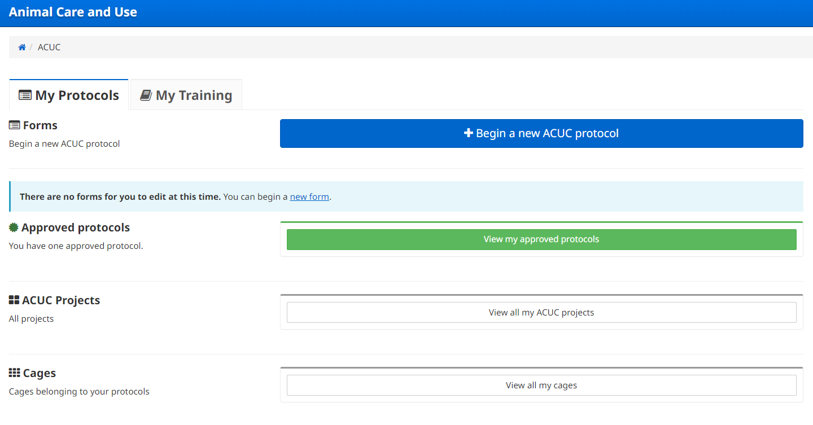

Submitting a protocol
- To submit a new protocol, click on ‘Begin a new ACUC protocol’ as shown in the above image.
- The eCompliance protocol form is similar to the previous paper protocol form with a few differences:
  - Project funding and personnel are listed under Section 13 – Project Information. This is where training and qualifications can be entered for each research personnel. Please be sure to include which procedures personnel will complete as well as any responsibilities.
  - Animal numbers including species, age/weight, pain/distress category and any possible phenotypic consequences can be found in Section 2 – Species Section.
  - The literature search will only be required for protocols involving procedures that may cause more than momentary or slight pain or distress to the animals or USDA covered species or Category E animals. The literature search can be found in Section 14 – Literature Search.
  - All substances used in the protocol will be listed in Section 7 – Substances Used in Animals, and this is where any non-pharmaceutical grade substances will be listed. This is also where any hazardous substances are listed, and if ‘Yes’ is checked to indicate a substance is hazardous additional information will be required in Section 8 – Hazardous Materials.
  - Breeding colony procedures and any photography and/or videotaping in the LARC should be described in Section 3 – Proposal Overview.
  - Any associated documents to be reviewed with the protocol should be added in Section 17 – Attached Files.

Submitting Revisions as the PI
- When the IACUC reviews your protocol and has returned comments you will receive an email notification. There will be a link that will take you to your protocol in eCompliance.
- You can edit your protocol by clicking ‘Edit Form’. This is where you will see reviewer comments and required modifications.
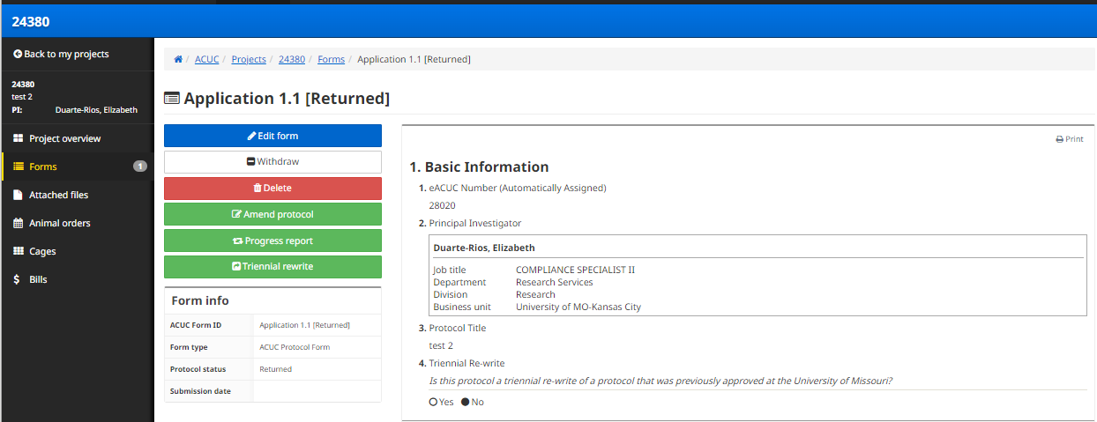
- If there are comments on multiple sections of your protocol, you can click on a comment in the Summary section to make the needed edits. To view the other comments, click on ‘Introduction’ in the menu on the left-hand side to return to the comment summary. Once you have made all necessary revisions, resubmit your study for review.
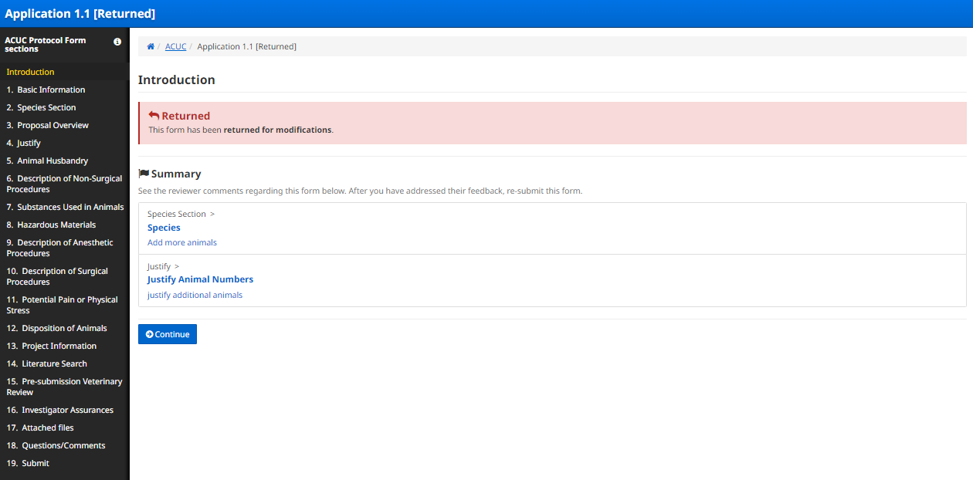

Amendments
- To submit an amendment, open the approved protocol in ‘My Projects’ and click ‘Amend protocol’ (see image below). Make any revisions to the protocol necessary and submit the protocol for review.
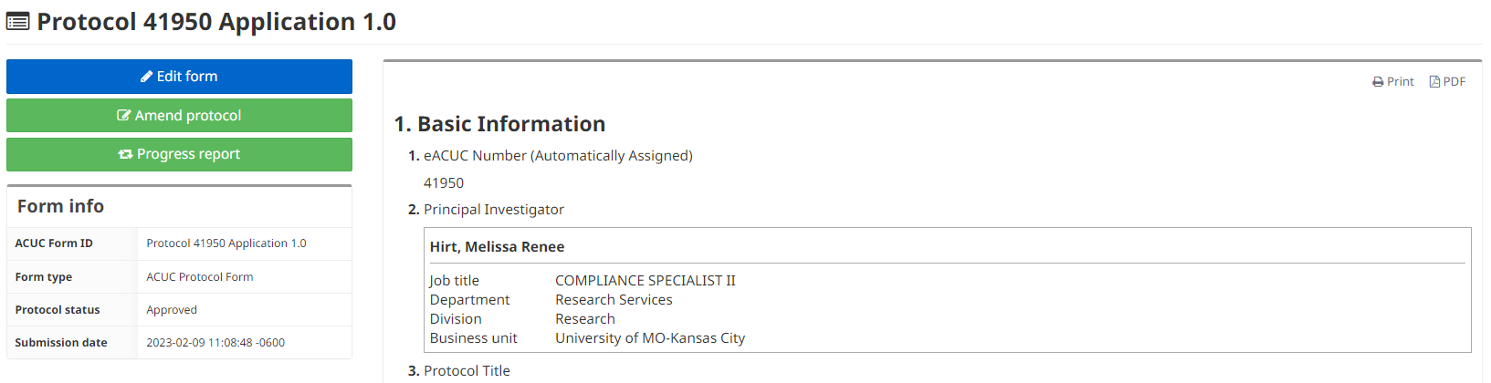
Annual Continuation
- To submit an Annual Continuation of an active protocol, open the protocol in ‘My projects’ and select ‘Progress report’ (see image above).

Three-Year Renewal
- To submit a Three-Year Renewal for an active protocol, open the approved protocol and click on ‘Triennial rewrite’. This will populate the approval protocol to allow for any needed revisions (you will not need to submit a separate, new application for the 3-Year Renewal). Once you have provided the 3 Year Progress Report and revised your protocol as needed, submit the renewal for review.

